PROJECT TITLE

Spring 2019

Group 9

Novem Tech

Phillip Hawkins

Edmund Osbourne

Shivam Patel

Dhanalakshmi Lakshmanan

**Resumes**

Phillip Hawkins (Coordinator):

* Experience: Intern at AppRiver
* Skills: C#, .NET, Linux, Git, HTML, CSS, Java, Python

Edmund Osbourne:

* Experience: 5+ years Freelance Programming
* Skills: C++,C,Java,C#, ARM assembly, Matlab,Javascript

Shivam Patel:

* Experience: University Technology Department
* Skills: Java, C, HTML, CSS, postgreSQL

Dhanalakshmi Lakshmanan:

* Experience: Application Support at VMware, Inc
* Skills: Java, SQL, Rest API, Firebase, Linux, HTML, CSS

**Planning and Scheduling**

|  |  |  |  |  |  |  |
| --- | --- | --- | --- | --- | --- | --- |
| **Assignee Name** | **Email** | **Task** | **Duration** | **Dependency** | **Due Date** | **Notes** |
| Phillip Hawkins | [phawkins4@student.gsu.edu](mailto:phawkins4@student.gsu.edu) | Coordinating group  Creating Github | ??? | None | Feb 05, 2019 |  |
| Edmund Osbourne | [eosborne5@student.gsu.edu](mailto:eosborne5@student.gsu.edu) | High Level System Architecture | 4 hours | Dhana | Feb 02, 2019 |  |
| Shivam Patel | [spatel223@student.gsu.edu](mailto:spatel223@student.gsu.edu) | Editing Final Report | 1 hour | Edmund | Feb 04, 2019 |  |
| Dhanalakshmi Lakshmanan | [dlakshmanan1@student.gsu.edu](mailto:dlakshmanan1@student.gsu.edu) | Draf project problem statement based on details provided by Shivam. | 2 hours | Shivam Patel | Feb 03, 2019 |  |

**Problem Statement**

Our Product is a complete banking system to be used by banks. The system is designed to facilitate all the needs of the banking staff as well as provide banking services to customers external to the bank.

Currently most larger banks such as Chase, Bank of America have their own banking systems these banks have the ability to have in large in house development teams to create and maintain modern features.This system allows for Small banks and credit unions provide all the modern features that customers are coming to expect. By providing this software the Smaller financial institutions do not have to have worry about having development teams as well as purchasing software designed for larger institutions.

With a comprehensive system designed for smaller institutions security becomes a lot easier to manage. A smaller concecise system means less of the budget has to go security. Systems for larger banks are more verbose and as a result can be a lot harder to monitor.

They’re are other companies such as finastra that provide banking system for small regional banks but our product is intended to be even more lightweight in its operation allowing the bank to spend less of its budget to technology. In the past a system like this would have to have been a big investment, but with the advent of new technologies in software and hardware, it is even more feasible to provide modern features at far lower cost. The trend in software is often to add more features and capacity with more computing resources. But what makes this product interesting is takes a slightly different approach using the improvements in technology to bring what was once only available to larger financial institutions to smaller ones.

**System Requirements**

This is a context view for a banking system aimed at small banks and credit unions. In this version the banking system is composed of seven different systems.

The **Teller/Banker System** is used by tellers and bankers in the branch to provide services to Customers.

Eg Deposits, withdrawals, counter checks, opening and closing accounts.

Authorization levels controls which employee can do what

The **Administration System** is used for system management

E.g. Adding and changing employee Credentials, Updating Customer Information

The **Online Banking System** consist of a website which can be used by the customer to complete typical banking task. Eg Checking balances, transfering money.

The **ATM System** is the provides automatic teller service at branches and handles ATM transactions from 3rd party banks.

E.g. allowing the use of 3rd party debit cards and charging appropriate fees

The **Loan System** Handles loan application and disbursements

E.g. Mortgages, Auto Loans, Personal loans

The **Investment System** Handles services related to customer investments accounts.

E.g. Certificate of deposits, Money Market Accounts

The **Credit Card/Line Of Credit System** Handles services related to Credit cards and Lines of credit

The **Telephony System** Provides a means for Customer to access account information through the phone

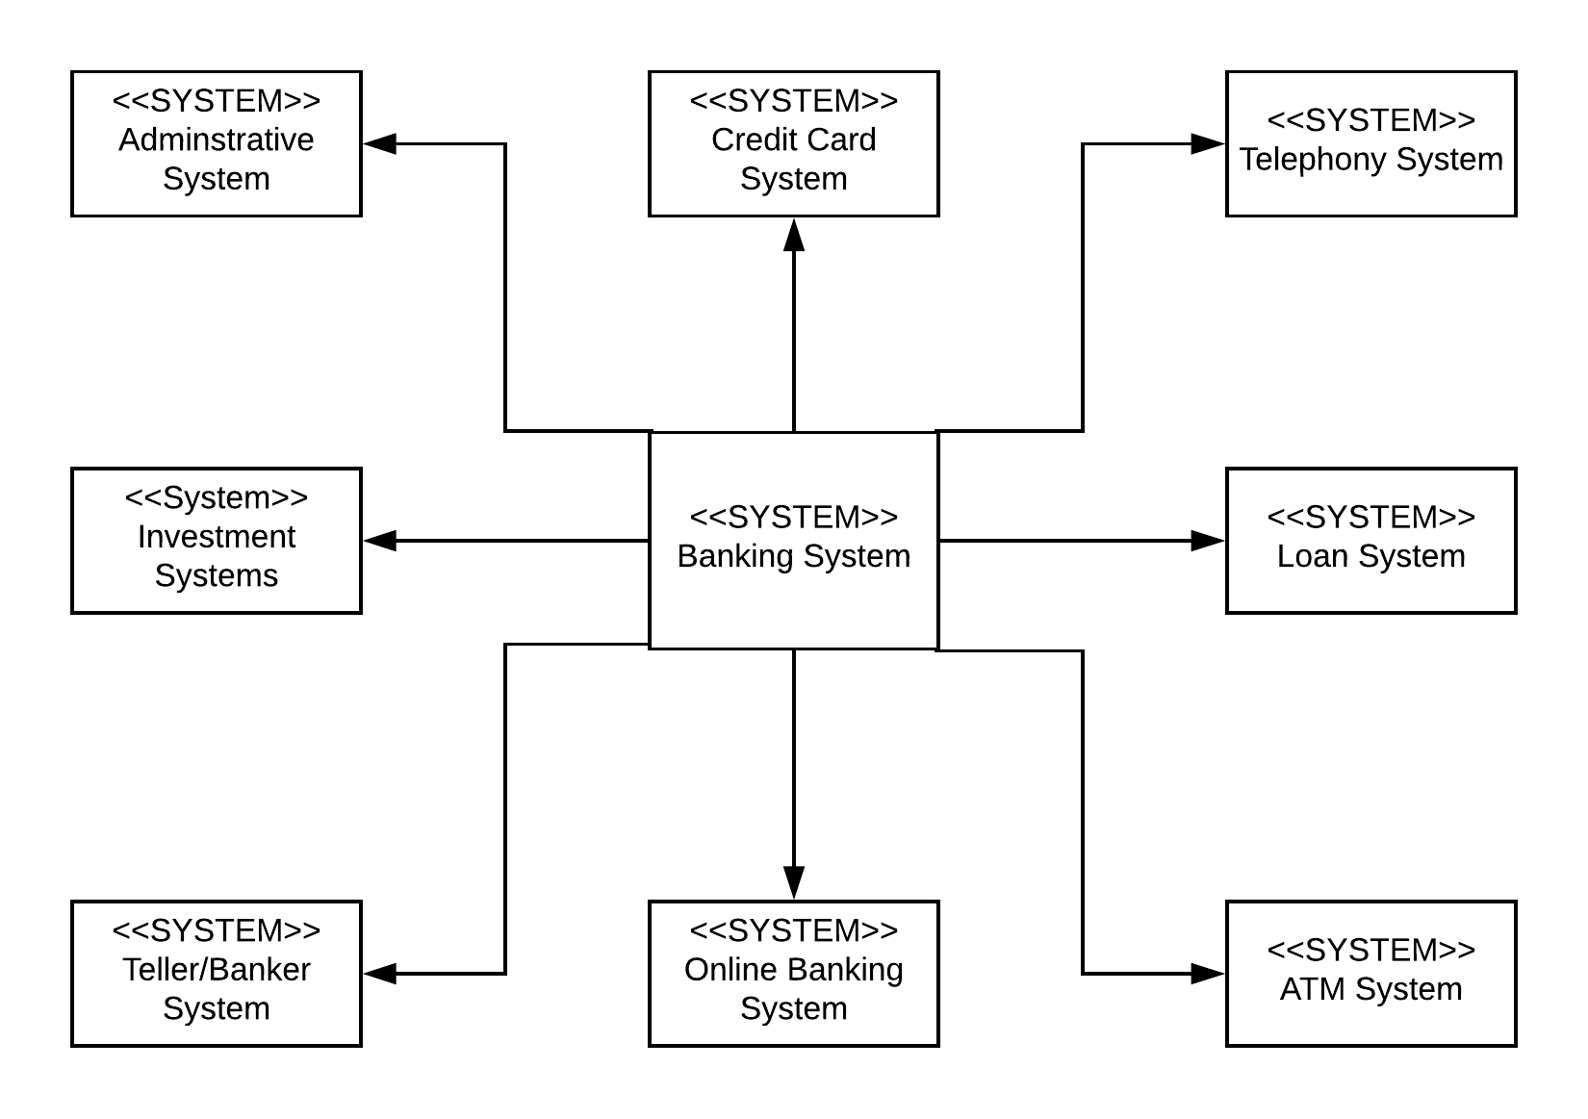

Context View Diagram

**Appendix**

GitHub Link: <https://github.com/novem-technology/CSC-SWE-Novem-Technology>